**Project Design Phase-II**

**Data Flow Diagram & User Stories**

|  |  |
| --- | --- |
| Date | 25 OCTOBER 2022 |
| Team ID | PNT2022TMID08321 |
| Project Name | Project – Crude Oil Price Prediction |
| Maximum Marks | 4 Marks |

**Data Flow Diagrams:**

A Data Flow Diagram (DFD) is a traditional visual representation of the information flows within a system. A neat and clear DFD can depict the right amount of the system requirement graphically. It shows how data enters and leaves the system, what changes the information, and where data is stored.

Example: DFD Level 0 (Industry Standard)

**Example:** [**(Simplified)**](https://developer.ibm.com/patterns/visualize-unstructured-text/)

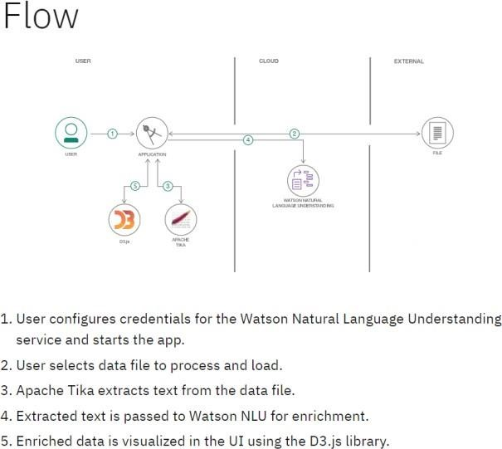 **`**

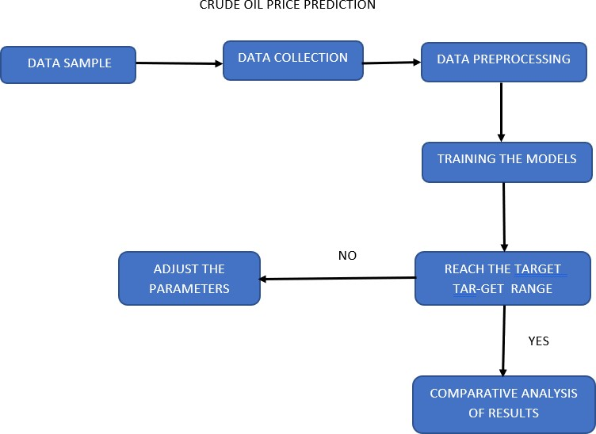

**User Stories**

Use the below template to list all the user stories for the product.

|  |  |  |  |
| --- | --- | --- | --- |
| **User Type** | **Functional**  **Requirement (Epic)** | **User Story Number** | **User Story / Task** |
| Predictors (made  prediction for future use) | Data Analysis and Collection | USN-1 | As a user, I can analysis of influencing factors of crude oil prices through various web pages. |
|  |  | USN-2 | Data samples were collected from famous websites like Kaggle etc.. |
|  |  | USN-3 | The collected data will be processed to remove the raw data from the datasets. |
|  | Pre-processing | USN-4 | The pre-processed data will be put in, for the training and splitting of the models. |
|  | Training models | USN-5 | The trained data will be checked for the target range that is set by the user |
|  |  | USN-6 | If User range is not yet meet. again the data is put in for training. |
|  |  | USN-7 | Attempt is made until the range is reached. |
|  | Predicted value | USN-8 | Once the range is reached will be compared with previous results to obtain the correct predicted value |